VHDL Implementation Report
Lane Detection using Sobel Filter on Artix-7 FPGA

Abstract
This project implements a simple lane-edge detection system using VHDL on an Artix-7 FPGA. The system does not use a live camera input. Instead, a fixed 160 x 120 grayscale road image is stored inside the FPGA as a ROM. The VGA controller scales and displays this image on a 640 x 480 VGA monitor. A 3x3 Sobel filter processes the pixel stream and highlights strong brightness changes, which correspond to edges such as lane markings and road boundaries. A single switch, SW0, selects between the original road image and the Sobel edge-detected output. The design demonstrates basic FPGA image processing, VGA display generation, and modular VHDL design.
Keywords: FPGA, VHDL, Sobel filter, lane detection, image ROM, VGA, Artix-7, Nexys A7

1. Introduction
Lane detection is an important concept in computer vision and driver-assistance systems. In this project, the goal is not to build a full camera-based automotive system, but to demonstrate the basic hardware idea of image edge detection on an FPGA. The Sobel filter is used because it is simple, well-known, and suitable for a hardware implementation.
The FPGA reads a stored road image pixel by pixel, processes it using the Sobel filter, and displays the result on a VGA monitor. This approach keeps the design manageable and allows the main focus to remain on VHDL implementation, FPGA resources, and VGA output.

2. Objective of the VHDL Part
The objective of the VHDL implementation is to create a complete digital image-processing pipeline inside the FPGA. The design must generate VGA timing, read image data from ROM, calculate Sobel edges, select the display mode, and send the result to the VGA output.
- Store a fixed grayscale road image inside FPGA ROM.
- Generate 640 x 480 VGA timing signals.
- Read and scale a 160 x 120 image to fit the VGA screen.
- Apply a 3x3 Sobel edge filter to the pixel stream.
- Use SW0 to select original image or Sobel edge output.
- Display the selected output on a VGA monitor.

3. System Overview
The design is built with four main VHDL source files and one constraint file. The top module connects the design together. The VGA display module creates timing and screen coordinates. The image ROM stores the grayscale road picture. The Sobel filter module performs the edge detection. The XDC file maps the logical ports to the physical pins of the Artix-7 FPGA board.

4. Block Diagram
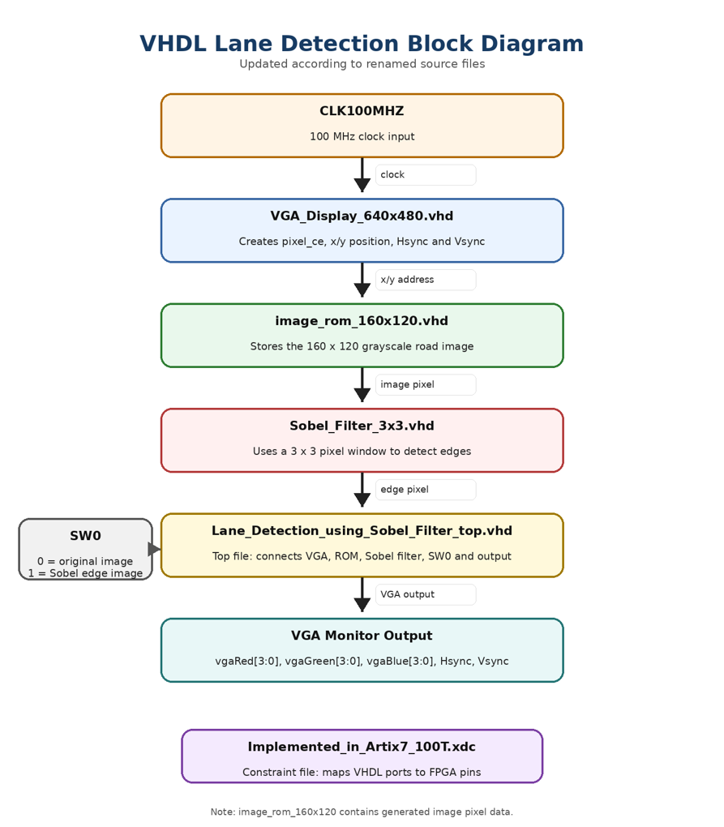
Figure 1: VHDL block diagram for the ROM-based Sobel lane detection design.

5. VHDL Source Files
File | Main role | Simple explanation
Lane_Detection_using_Sobel_Filter_top.vhd | Top-level integration | Connects all modules and selects original or Sobel output using SW0.
VGA_Display_640x480.vhd | VGA timing | Generates x/y position, pixel enable, visible signal, Hsync, and Vsync.
image_rom_160x120.vhd | Image storage | Stores the 160 x 120 grayscale road image as ROM values.
Sobel_Filter_3x3.vhd | Image processing | Builds a 3x3 pixel window and calculates Sobel edge strength.

5.1 Lane_Detection_using_Sobel_Filter_top.vhd
This file is the top-level VHDL module. It represents the complete project from the outside. The external inputs and outputs of the FPGA design are declared here, such as the 100 MHz clock, SW0, VGA color signals, Hsync, and Vsync.
The top file instantiates the other VHDL modules and connects them with internal signals. It connects the VGA timing module to the image ROM, sends the ROM pixel stream to the Sobel filter, and finally selects the output image using SW0. When SW0 is 0, the original image is shown. When SW0 is 1, the Sobel edge image is shown. This file is important because it controls how all separate parts of the project work together as one system.

5.2 VGA_Display_640x480.vhd
This file generates the VGA timing for a 640 x 480 display. A VGA monitor needs more than color values. It also needs synchronization signals to know when each line and each frame starts. The module therefore creates horizontal sync, vertical sync, visible area, and current pixel coordinates.
The FPGA board clock is 100 MHz, while VGA pixel timing is approximately 25 MHz for 640 x 480 output. Therefore, the module creates a pixel enable signal. This signal tells the rest of the design when one new pixel should be processed. In simple terms, this file tells the FPGA which screen pixel is currently being drawn.

5.3 image_rom_160x120.vhd
This file stores the road image used in the project. The image is saved as an 8-bit grayscale ROM. Each pixel value ranges from 0 to 255, where 0 means black and 255 means white.
The stored image resolution is 160 x 120 pixels. The VGA output is 640 x 480 pixels. Therefore, the top module scales the image by using the VGA coordinates divided by four. This makes the smaller ROM image fill the larger VGA screen while using much less FPGA memory than a full 640 x 480 image. Most of this file is generated pixel data. The important logic converts x and y image coordinates into a ROM address using the formula: address = y x image_width + x.

5.4 Sobel_Filter_3x3.vhd
This is the main image-processing module. It implements the Sobel edge detection algorithm. The Sobel filter detects strong changes in brightness. In a road image, lane markings and road boundaries usually create strong contrast, so they appear clearly in the edge output.
The module processes one pixel at a time, but the Sobel algorithm needs neighboring pixels. For that reason, the module stores previous lines and creates a moving 3x3 window of pixels. The Sobel calculation estimates horizontal and vertical brightness changes. Gx detects left-right changes and Gy detects top-bottom changes. The final edge strength is approximated as edge strength = |Gx| + |Gy|. If the edge strength is high, the output pixel becomes bright. If the edge strength is low, the output pixel becomes dark.

6. Working Principle
Step | Description
Step 1 | The 100 MHz clock is given to the FPGA design.
Step 2 | The VGA module generates x/y screen positions and sync signals.
Step 3 | The x/y position is scaled and used to read one pixel from image_rom_160x120.vhd.
Step 4 | The Sobel filter receives the pixel stream and builds a 3x3 window.
Step 5 | The Sobel filter calculates edge strength using Gx and Gy.
Step 6 | The top module uses SW0 to select original image or Sobel output.
Step 7 | The selected grayscale pixel is sent to VGA red, green, and blue outputs.
Step 8 | The VGA monitor displays the final image pixel by pixel.

7. Inputs and Outputs

7.1 Inputs
Input | Purpose
CLK100MHZ | Main 100 MHz clock for the FPGA design.
SW0 | Display mode switch: original image or Sobel edge output.

7.2 Outputs
Output | Purpose
vgaRed[3:0] | 4-bit red VGA output.
vgaGreen[3:0] | 4-bit green VGA output.
vgaBlue[3:0] | 4-bit blue VGA output.
Hsync | Horizontal synchronization signal for VGA.
Vsync | Vertical synchronization signal for VGA.

8. Display Modes
SW0 value | VGA display
0 | Original grayscale road image
1 | Sobel edge-detection output

9. Constraint File
The file Implemented_in_Artix7_100T.xdc is the Vivado constraint file. It maps the VHDL port names to the real FPGA pins. This is necessary because the VHDL code only describes logic, but the FPGA also needs to know which physical pins are connected to the clock, switch, and VGA connector.
- CLK100MHZ is connected to the board clock pin.
- SW0 is connected to the board switch pin.
- VGA red, green, blue, Hsync, and Vsync are connected to the VGA connector pins.

10. Verification and Testing
The design can be verified in two ways. First, the VHDL modules can be checked through simulation or testbench work. Second, the design can be tested on the FPGA board by generating the bitstream and observing the VGA monitor output.
The expected hardware test is simple: with SW0 set to 0, the original road image should be visible. With SW0 set to 1, the Sobel edge output should appear. This confirms that the image ROM, VGA timing, Sobel filter, and display selector are working together.

11. Limitations
- The design uses a stored image, not a live camera input.
- The Sobel filter detects all strong edges, not only lane markings.
- The 160 x 120 image is scaled to 640 x 480, so the displayed image is not high-resolution.
- This project is an educational FPGA image-processing demonstration, not a full autonomous driving system.

12. Conclusion
The VHDL implementation successfully demonstrates a basic FPGA-based lane edge detection system. The project uses a modular structure with four main source files: a top-level integration module, a VGA timing module, an image ROM module, and a Sobel filter module. The system reads a stored road image, applies Sobel edge detection, and displays the result on a VGA monitor.
This project shows how an FPGA can perform simple image processing directly in hardware. It also demonstrates important FPGA design concepts such as modular VHDL design, pixel-stream processing, ROM-based image storage, VGA synchronization, and hardware output selection using a switch.

Appendix A: Project File List
File | Description
Lane_Detection_using_Sobel_Filter_top.vhd | Top-level design and display selector.
VGA_Display_640x480.vhd | VGA timing generator.
image_rom_160x120.vhd | Stored grayscale road image.
Sobel_Filter_3x3.vhd | Sobel edge detection module.
Implemented_in_Artix7_100T.xdc | Vivado FPGA pin constraint file.

